

# CARE POINT

Laser Welder Settings

Press Memory button ‘MEM’ ONCE only – Arrow will point left for 3 seconds only, during which time +/- can be used to select required program.

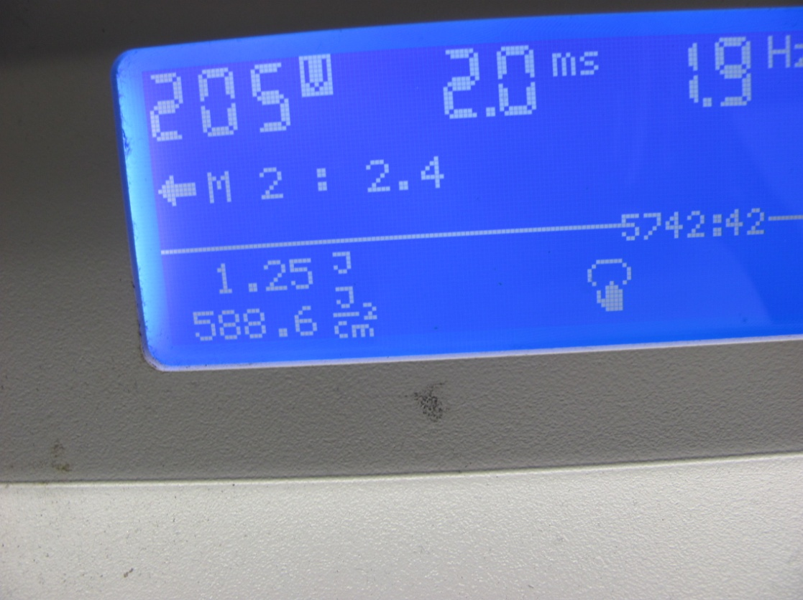

Arrow pointing left.

DO NOT ATTEMPT TO CHANGE PROGRAM IF ARROW IS POINTING TO THE RIGHT (this may accidentally rename the program!).

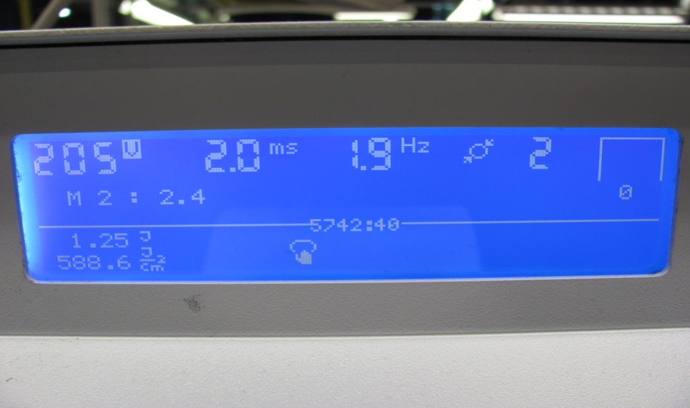

Preset Memory2 M2 is for 2.4mm springs

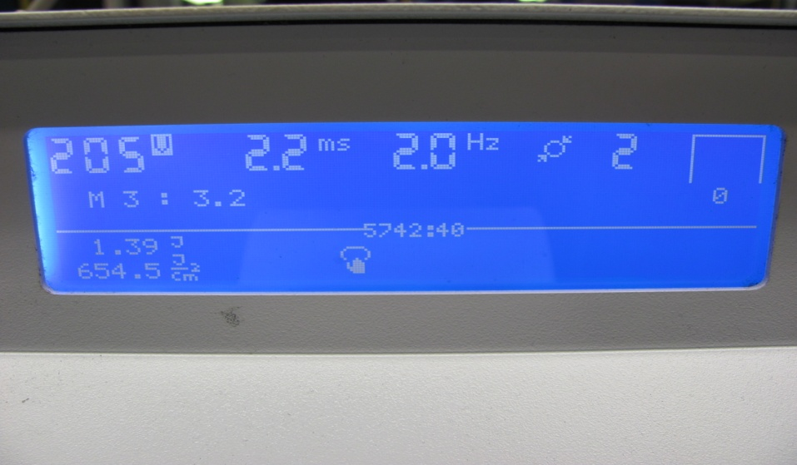

Preset Memory3 M3 is for 3.2mm springs

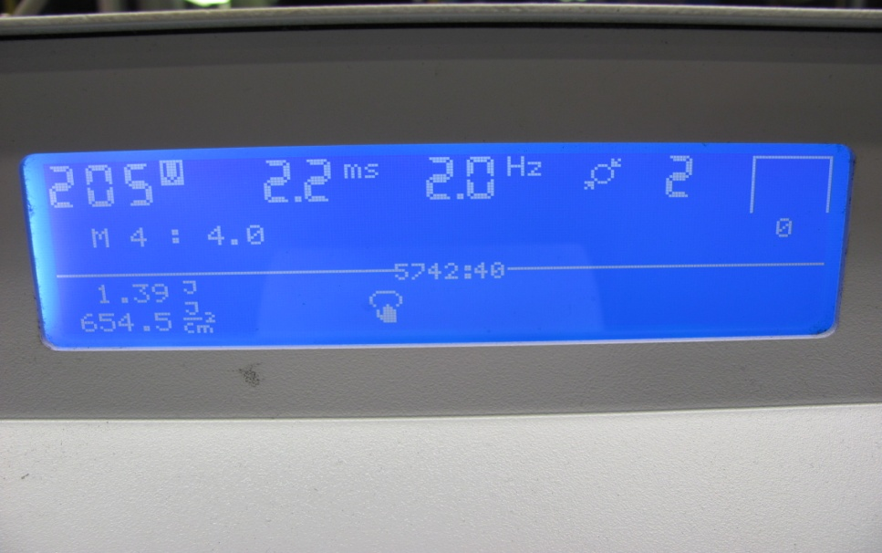

Preset Memory4 M4 is for 4.0mm springs

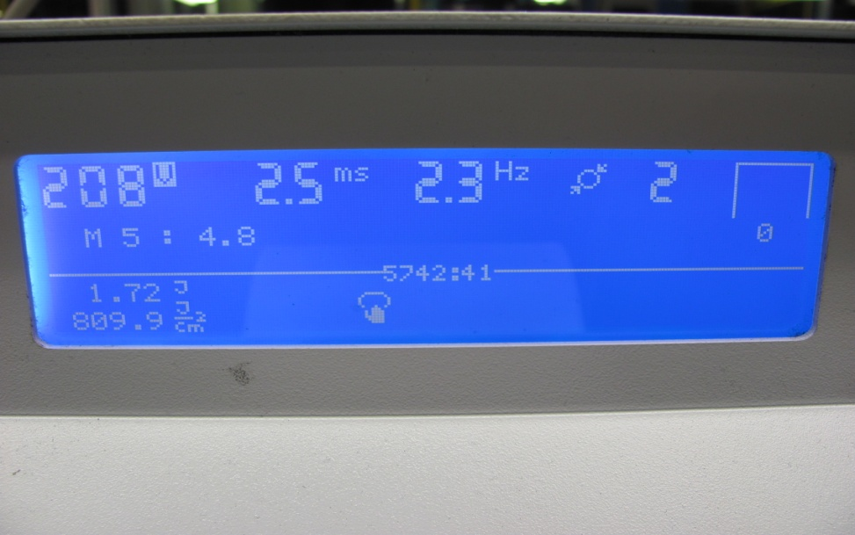Preset Memory5 M5 is for 4.8mm springs

THESE SETTINGS MUST NOT BE ALTERED

IF THEY DO NOT APPEAR AS ABOVE INFORM SUPERVISION IMMEDIATELY